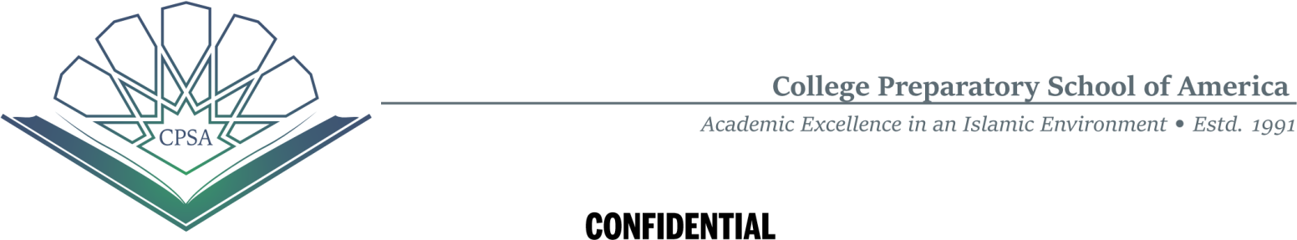
2024-25 Application for Financial Hardship Discount (FHD)
Parents
Father: ____________________________________________________________________________
Occupation: _______________________ Employer: _______________________________________
Mother: ___________________________________________________________________________
Occupation: _______________________ Employer: _______________________________________
(Provide Guardian information if applicable in place of parents)
Address: ________________________________________________________
Day Phone: _____________________________ Evening Phone: _____________________________
Cell Phone: ______________________________
E-Mail Address: __________________________________________
Number of Family Members: Adults_______ Children: ______
Number of children in college: _______ Number of children married/not living with parents: _______
CPSA Student Full Name | Gender | Grade  Level  2024-25 | GPA  2023-24 | Calculated Tuition Fee | Discount Given | Tuition  Fee  Assigned
List student’s names in order of higher to lower grade level. Shaded areas for CPSA office use only.
Note to Parents – All students are required to maintain a GPA of 3.5 throughout the year.
Please circle one - Are you eligible for Zakat: Yes or No
Combined Family Monthly Income for 2023: ___________________ (must include last 4 pay stubs of both the parents)
Adjusted Gross Income from the parents most recent federal income tax return: ______________________ If filing separately, Adjusted Gross Income from the wife’s most recent federal tax return: ________________ Do you own business? YES: ______ NO: ______ Submit copy of business tax return.
Do you own any rental property: YES: ______ NO: _______ Monthly Income: _______________

Other Monthly Income:
Child support received: $_______________ Social Security benefits that were not taxed: $______________
Tuition Support (Sponsor) anticipated from friends/relatives/employer: $_________________
Name/Phone Number of Sponsor: ______________________________________________________________ Unemployment Benefits Payment: $______________Other non-taxable income: $________________
Assets:
Value of cash, savings and checking accounts: $__________________
Value of stocks, mutual funds and other investments: $_________________
Value of retirement plan assets: $________________
If you own your home, what is the estimated market value: $_________________
Average Monthly Expenses:
Electricity: $_____________Heating/Cooking Gas: $_____________ Groceries: $______________
Water: $_______________Rent/Mortgage: ______________ Health Insurance: $_____________
Car Payments: ______________ Auto Insurance: $_________________
Misc. (Specify): __________________________________________________________________________
Additional Information:
You may use a separate page to explain special circumstances with information such as parent’s volunteering work with CPSA, Alumni parents etc. that you feel might be helpful in determining your family’s qualification for tuition assistance.
We hereby declare that all the information stated and submitted is current and accurate to the best of our knowledge. CPSA reserves the right to rescind the full amount of any tuition assistance and demand full payment of all tuition and fees should any of the information included in this application or any supporting documents are found to be untrue.

Signatures:
Father: _____________________________________________ Date: ________________________________
Mother: ____________________________________________ Date: ________________________________
Total Tuition Fees Paid: $
Number of children in CPSA = Grades:
FHD Committee Chairperson Signature/Date:
FHD Committee Member Signature/Date: |  | 2024-25 Discounted Fees per month  $
FHD Committee Member Signature/Date: |  | By Parents $ | From Zakat $ | By Sponsor $

----------------FOR OFFICE USE ONLY – BELOW THIS LINE ---------------------

Application No. Family Full Name For 2024-25

The required copy of documents with the application form
Without these documents, CPSA will not be able to process the application. All documents received by CPSA are kept secured and confidential. Below is the checklist.
- Tax return Form 1040 for 2023 from IRS office for both parents or joint return for joint filers
- All 2022 W-2 Wage and Tax Statements for both the parents
- Last four paycheck stubs for 2024 (one or both parents)
- Business tax return for 2023 if you have your own business (one or both parents)
- Quarterly tax payment if you have your own business (one or both parents)
- Current bill for the electricity
- Current bill for the heating/cooking gas
- Current bill for the water
- Current rent/mortgage payment
- Current Auto and Home Insurance
- Current car(s) payment
- Other income such as social security, child support, worker’s compensation etc.
- Other expenses-payments (please specify)
- Student(s) Report Card (Transcript) from last year
- Additional information below or on a separate page

